Ray Containment in a Line

Definition
# Source: AI Source: Provided by: [Data Path: Persons Table -> ID Column: 1, Name_En Column: Motasem Essam] -> From: [ChatGPT] on [7/25/2026]
Ray Containment in a Line occurs when a ray lies entirely within its supporting line.
A ray has one endpoint and extends infinitely in one direction, while a line extends infinitely in both directions. Therefore, every point of a ray belongs to the line that contains it.
For a ray starting at $A$and passing through $B$:
$$\boxed{\vec{AB}⊂\overset{↔}{AB}}$$
This means that the ray $\vec{AB}$is contained in the line $\overset{↔}{AB}$.
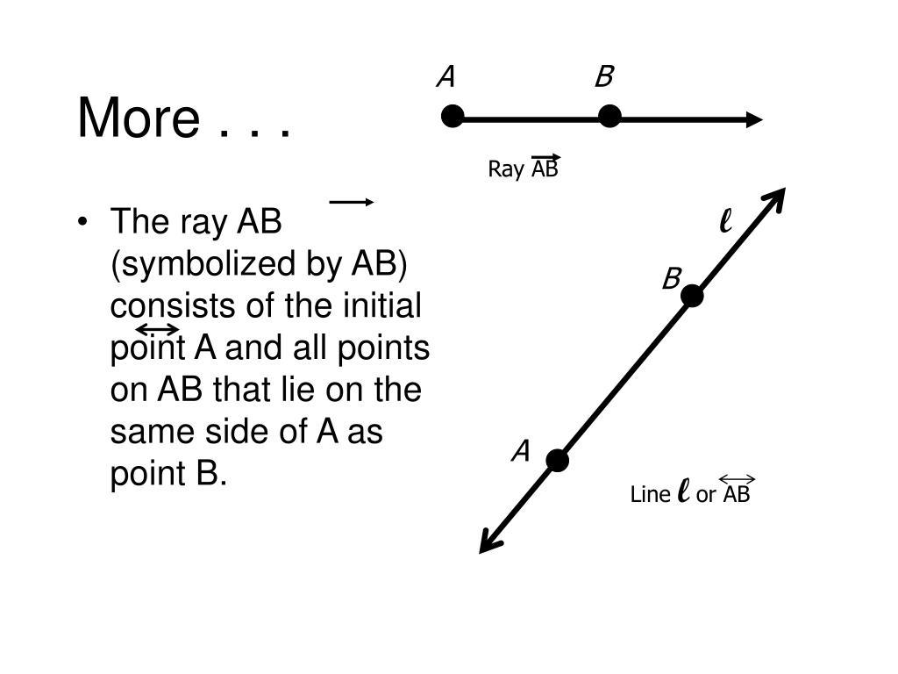
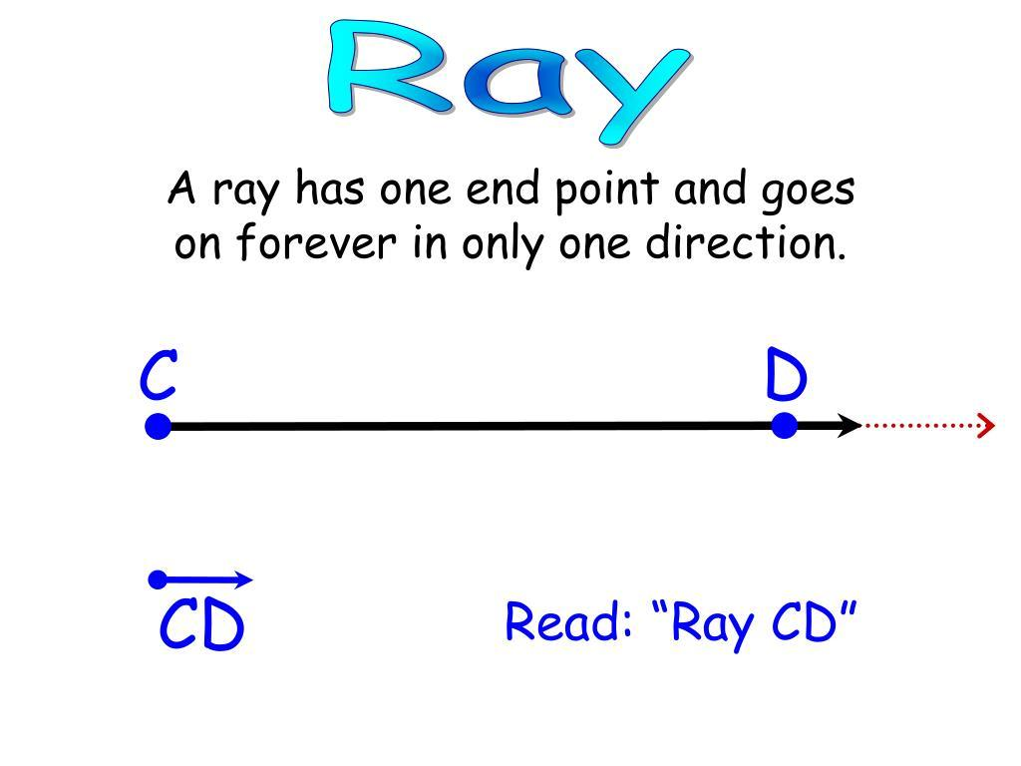
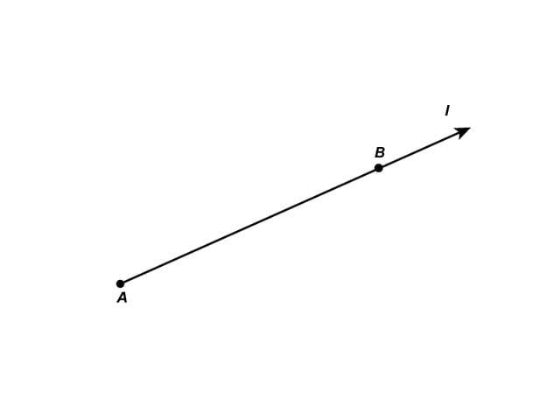
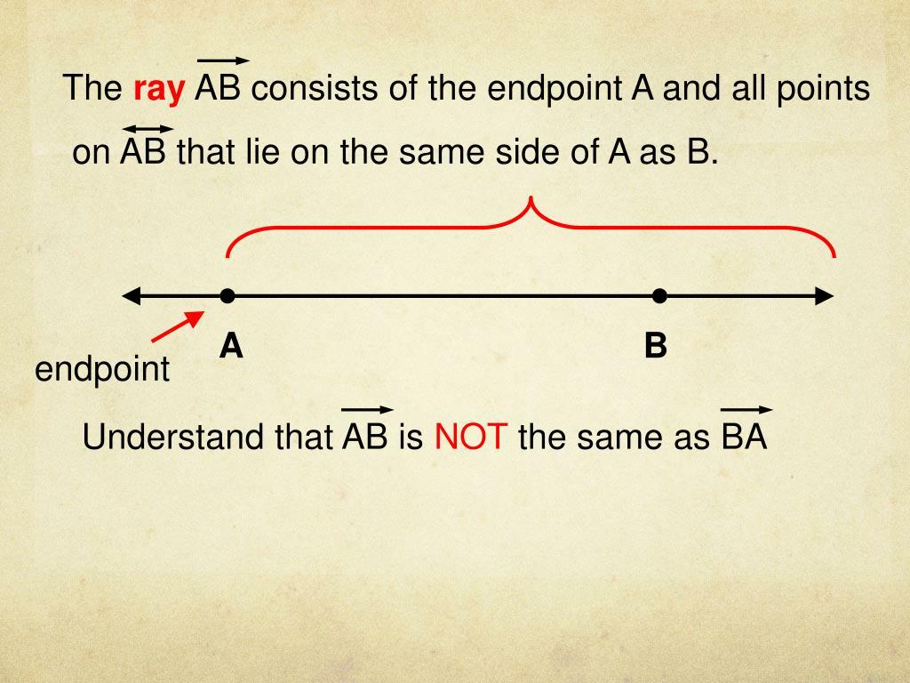
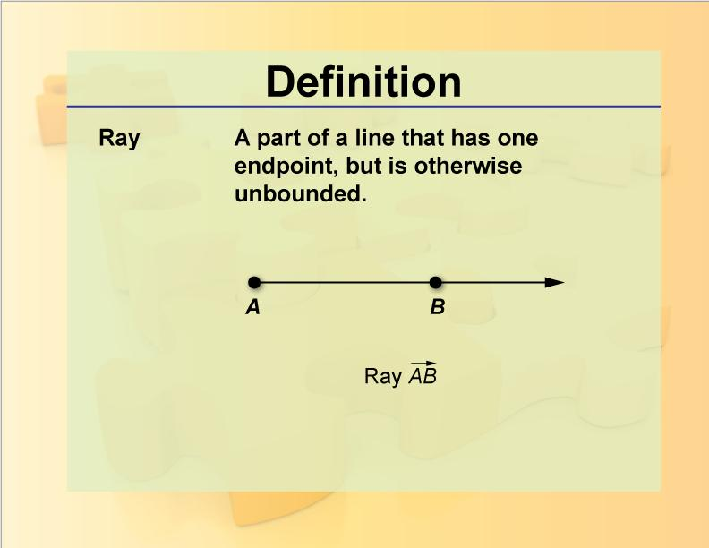

Purpose
# Source: AI Source: Provided by: [Data Path: Persons Table -> ID Column: 1, Name_En Column: Motasem Essam] -> From: [ChatGPT] on [7/25/2026]
Ray containment in a line is used to describe the positional relationship between a ray and the line that supports it.
It helps establish that:
- Every point on a ray is also on its supporting line.
- A ray is a subset of a line.
- A ray extends infinitely in one direction.
- The supporting line extends infinitely in both directions.
- A ray and its supporting line are not equal because their extents are different.

Fundamental Concept
# Source: AI Source: Provided by: [Data Path: Persons Table -> ID Column: 1, Name_En Column: Motasem Essam] -> From: [ChatGPT] on [7/25/2026]
Consider the ray:
$$\vec{AB}$$
and its supporting line:
$$\overset{↔}{AB}$$
The ray begins at $A$, passes through $B$, and continues infinitely beyond $B$.
The line passes through $A$and $B$and continues infinitely in both directions.
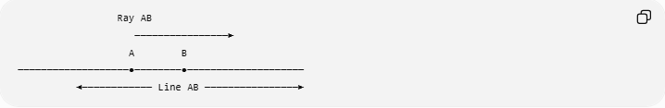
Ray AB
────────────────►
A B
───────────────────●────────●────────────────────
◄──────────── Line AB ────────────────►
The ray occupies only one half of the line.
Therefore:
$$\boxed{\vec{AB}⊊\overset{↔}{AB}}$$
The symbol $⊊$indicates a proper subset.

Mathematical Representation

Set Representation of a Ray
# Source: AI Source: Provided by: [Data Path: Persons Table -> ID Column: 1, Name_En Column: Motasem Essam] -> From: [ChatGPT] on [7/25/2026]
A ray can be represented parametrically as:
$$\vec{AB}=\left\{A+t\left(B-A\right)∣t≥0\right\}$$
The condition
$$t≥0$$
means that the ray starts at $A$and extends through $B$indefinitely.

Set Representation of the Line
# Source: AI Source: Provided by: [Data Path: Persons Table -> ID Column: 1, Name_En Column: Motasem Essam] -> From: [ChatGPT] on [7/25/2026]
The corresponding line is:
$$\overset{↔}{AB}=\left\{A+t\left(B-A\right)∣t∈R\right\}$$
Here $t$can be any real number, allowing the line to extend in both directions.
Since:
$$t≥0 ⇒ t∈R$$
we obtain:
$$\boxed{\vec{AB}⊂\overset{↔}{AB}}$$

Point-by-Point Interpretation
# Source: AI Source: Provided by: [Data Path: Persons Table -> ID Column: 1, Name_En Column: Motasem Essam] -> From: [ChatGPT] on [7/25/2026]
If a point $P$belongs to the ray:
$$P∈\vec{AB}$$
then that same point must belong to the supporting line:
$$\boxed{P∈\vec{AB}⇒P∈\overset{↔}{AB}}$$
However, the reverse statement is not generally true.
A point can belong to the line without belonging to the ray:
$$P∈\overset{↔}{AB}⇏P∈\vec{AB}$$
For example:
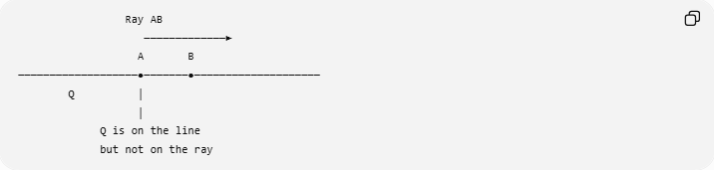
Ray AB
─────────────►
A B
───────────────────●───────●────────────────────
Q │
│
Q is on the line
but not on the ray
A point $Q$located behind $A$is on the line but not on the ray $\vec{AB}$.

Fundamental Elements
# Source: AI Source: Provided by: [Data Path: Persons Table -> ID Column: 1, Name_En Column: Motasem Essam] -> From: [ChatGPT] on [7/25/2026]
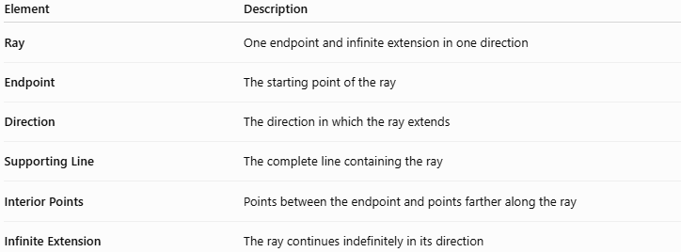
Element | Description
Ray | One endpoint and infinite extension in one direction
Endpoint | The starting point of the ray
Direction | The direction in which the ray extends
Supporting Line | The complete line containing the ray
Interior Points | Points between the endpoint and points farther along the ray
Infinite Extension | The ray continues indefinitely in its direction

Example
# Source: AI Source: Provided by: [Data Path: Persons Table -> ID Column: 1, Name_En Column: Motasem Essam] -> From: [ChatGPT] on [7/25/2026]
Consider:
$$A=\left(1 , 2\right)$$
and
$$B=\left(5 , 2\right)$$
The ray beginning at $A$and passing through $B$is:
$$\vec{AB}$$
Its supporting line is:
$$y=2$$
The ray consists of:
$$\boxed{x≥1, y=2}$$
while the entire line consists of:
$$\boxed{-∞<x<∞, y=2}$$
Therefore:
$$\vec{AB}⊊\overset{↔}{AB}$$
Point $P=\left(8 , 2\right)$
Since $P$is beyond $B$in the same direction:
$$P∈\vec{AB}$$
and therefore:
$$P∈\overset{↔}{AB}$$
Point $Q=\left(- , 32\right)$
$Q$lies on the line:
$$Q∈\overset{↔}{AB}$$
but it lies behind the endpoint $A$, so:
$$Q∉\vec{AB}$$

Important Properties

1. Every ray has a supporting line
# Source: AI Source: Provided by: [Data Path: Persons Table -> ID Column: 1, Name_En Column: Motasem Essam] -> From: [ChatGPT] on [7/25/2026]
For two distinct points $A$and $B$, the ray
$$\vec{AB}$$
has the unique supporting line:
$$\overset{↔}{AB}$$

2. The ray is a subset of the line
# Source: AI Source: Provided by: [Data Path: Persons Table -> ID Column: 1, Name_En Column: Motasem Essam] -> From: [ChatGPT] on [7/25/2026]
$$\boxed{\vec{AB}⊂\overset{↔}{AB}}$$

3. The containment is proper
# Source: AI Source: Provided by: [Data Path: Persons Table -> ID Column: 1, Name_En Column: Motasem Essam] -> From: [ChatGPT] on [7/25/2026]
The ray does not contain the entire line:
$$\boxed{\vec{AB}⊊\overset{↔}{AB}}$$
because the line also contains points extending in the direction opposite to the ray.

4. The endpoint belongs to both
# Source: AI Source: Provided by: [Data Path: Persons Table -> ID Column: 1, Name_En Column: Motasem Essam] -> From: [ChatGPT] on [7/25/2026]
The endpoint $A$satisfies:
$$A∈\vec{AB}$$
and:
$$A∈\overset{↔}{AB}$$

5. Points beyond $B$remain on the ray
# Source: AI Source: Provided by: [Data Path: Persons Table -> ID Column: 1, Name_En Column: Motasem Essam] -> From: [ChatGPT] on [7/25/2026]
If $P$lies beyond $B$in the direction from $A$toward $B$, then:
$$P∈\vec{AB}$$
and:
$$P∈\overset{↔}{AB}$$

6. Points behind the endpoint are not on the ray
# Source: AI Source: Provided by: [Data Path: Persons Table -> ID Column: 1, Name_En Column: Motasem Essam] -> From: [ChatGPT] on [7/25/2026]
A point can satisfy:
$$P∈\overset{↔}{AB}$$
while:
$$P∉\vec{AB}$$
if it lies on the opposite side of $A$.

Ray Direction Matters
# Source: AI Source: Provided by: [Data Path: Persons Table -> ID Column: 1, Name_En Column: Motasem Essam] -> From: [ChatGPT] on [7/25/2026]
The rays
$$\vec{AB}$$
and
$$\vec{BA}$$
have the same supporting line, but they point in opposite directions.
Therefore:
$$\vec{AB}⊊\overset{↔}{AB}$$
and:
$$\vec{BA}⊊\overset{↔}{AB}$$
but generally:
$$\boxed{\vec{AB}≠\vec{BA}}$$
Their intersection is only their common endpoint:
$$\boxed{\vec{AB}∩\vec{BA}=\left\{A , B\right\}}$$
when $A$and $B$are distinct.

Coordinate Representation
# Source: AI Source: Provided by: [Data Path: Persons Table -> ID Column: 1, Name_En Column: Motasem Essam] -> From: [ChatGPT] on [7/25/2026]
For:
$$A=\left(x_{1} , y_{1}\right)$$
and:
$$B=\left(x_{2} , y_{2}\right)$$
the ray can be represented as:
$$\left(x , y\right)=\left(x_{1} , y_{1}\right)+t\left(x_{2} , -x_{1}y_{2}-y_{1}\right), t≥0$$
The supporting line uses:
$$t∈R$$
Thus:
$$\boxed{\vec{AB}=\left\{A+t\left(B-A\right)∣t≥0\right\}}$$
and:
$$\boxed{\overset{↔}{AB}=\left\{A+t\left(B-A\right)∣t∈R\right\}}$$

Containment Relationship
# Source: AI Source: Provided by: [Data Path: Persons Table -> ID Column: 1, Name_En Column: Motasem Essam] -> From: [ChatGPT] on [7/25/2026]
The basic containment hierarchy is:
$$\boxed{\overset{‾}{AB}⊊\vec{AB}⊊\overset{↔}{AB}}$$
This means:
Line Segment → Ray → Line
Each object is contained within the next larger geometric object.
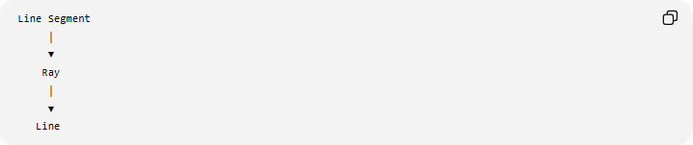
Line Segment
│
▼
Ray
│
▼
Line

Ray Containment in a Line vs. Point Containment in a Line
# Source: AI Source: Provided by: [Data Path: Persons Table -> ID Column: 1, Name_En Column: Motasem Essam] -> From: [ChatGPT] on [7/25/2026]
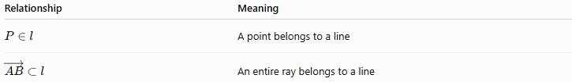
Relationship | Meaning
$$P∈l$$ | A point belongs to a line
$$\vec{AB}⊂l$$ | An entire ray belongs to a line
Point containment concerns one point, whereas ray containment concerns every point of an entire ray.

Ray Containment in a Line vs. Segment Containment in a Line
# Source: AI Source: Provided by: [Data Path: Persons Table -> ID Column: 1, Name_En Column: Motasem Essam] -> From: [ChatGPT] on [7/25/2026]
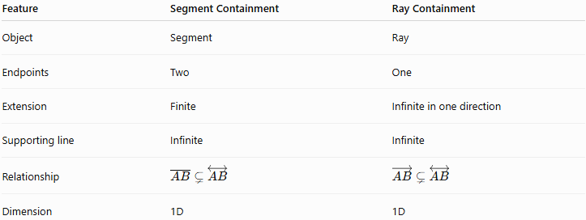
Feature | Segment Containment | Ray Containment
Object | Segment | Ray
Endpoints | Two | One
Extension | Finite | Infinite in one direction
Supporting line | Infinite | Infinite
Relationship | $$\overset{‾}{AB}⊊\overset{↔}{AB}$$ | $$\vec{AB}⊊\overset{↔}{AB}$$
Dimension | 1D | 1D
Both are contained in their supporting line, but the ray extends infinitely in one direction while the segment is finite.

Ray Containment in a Line vs. Coincidence
# Source: AI Source: Provided by: [Data Path: Persons Table -> ID Column: 1, Name_En Column: Motasem Essam] -> From: [ChatGPT] on [7/25/2026]
These concepts should not be confused.
Containment
$$\vec{AB}⊊\overset{↔}{AB}$$
The ray occupies only part of the line.
Coincidence
Coincidence means two geometric objects completely occupy the same geometric set.
A ray and a line cannot be coincident, because a ray does not extend in both directions.

Ray Containment and Intersection
# Source: AI Source: Provided by: [Data Path: Persons Table -> ID Column: 1, Name_En Column: Motasem Essam] -> From: [ChatGPT] on [7/25/2026]
Because:
$$\vec{AB}⊆\overset{↔}{AB}$$
their intersection is the entire ray:
$$\boxed{\vec{AB}∩\overset{↔}{AB}=\vec{AB}}$$
This is a consequence of containment.
Therefore, containment is the primary relationship, while the intersection describes the common set.

Geometric Interpretation
# Source: AI Source: Provided by: [Data Path: Persons Table -> ID Column: 1, Name_En Column: Motasem Essam] -> From: [ChatGPT] on [7/25/2026]
A ray can be thought of as one half of a line starting at an endpoint.
For example:
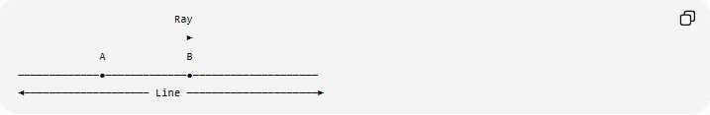
Ray
►
A B
─────────────●─────────────●────────────────────
◄──────────────────── Line ─────────────────────►
The line contains:
- the ray extending from $A$through $B$;
- the opposite ray extending from $A$in the other direction.
Thus the line can be decomposed into two opposite rays:
$$\boxed{\overset{↔}{AB}=\vec{AB}∪\vec{BA}}$$
and:
$$\vec{AB}∩\vec{BA}=\left\{A\right\}$$

Real-World Applications
# Source: AI Source: Provided by: [Data Path: Persons Table -> ID Column: 1, Name_En Column: Motasem Essam] -> From: [ChatGPT] on [7/25/2026]
1. Engineering Drawings
A direction from a fixed point can be represented as a ray contained within a construction line.
2. CAD
Computer-aided design systems use rays for:
- ray casting;
- geometric modeling;
- object detection;
- intersection calculations.
3. Computer Graphics
Rays are used in:
- ray tracing;
- lighting calculations;
- visibility testing;
- collision detection.
4. Robotics
A robot's sensor or movement direction can be mathematically modeled as a ray contained in a reference line.
5. Coordinate Geometry
The relationship provides a simple way to distinguish:
- finite objects;
- one-direction infinite objects;
- two-direction infinite objects.

Comparison with Related Concepts
# Source: AI Source: Provided by: [Data Path: Persons Table -> ID Column: 1, Name_En Column: Motasem Essam] -> From: [ChatGPT] on [7/25/2026]
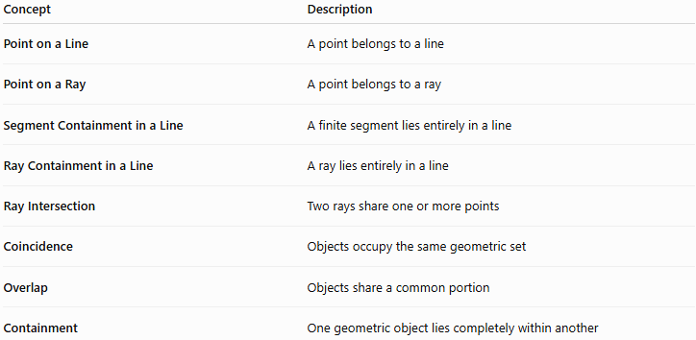
Concept | Description
Point on a Line | A point belongs to a line
Point on a Ray | A point belongs to a ray
Segment Containment in a Line | A finite segment lies entirely in a line
Ray Containment in a Line | A ray lies entirely in a line
Ray Intersection | Two rays share one or more points
Coincidence | Objects occupy the same geometric set
Overlap | Objects share a common portion
Containment | One geometric object lies completely within another

Key Points
# Source: AI Source: Provided by: [Data Path: Persons Table -> ID Column: 1, Name_En Column: Motasem Essam] -> From: [ChatGPT] on [7/25/2026]
- A ray is completely contained in its supporting line.
- The fundamental relationship is:
$$\boxed{\vec{AB}⊊\overset{↔}{AB}}$$
- A ray has one endpoint.
- A ray extends infinitely in one direction.
- A line extends infinitely in two directions.
- Every point on the ray is also a point on the line.
- Not every point on the line belongs to the ray.
- The direction of the ray matters.
- $\vec{AB}$and $\vec{BA}$have the same supporting line but opposite directions.
- Ray containment is a containment relationship, not coincidence.

Conclusion
# Source: AI Source: Provided by: [Data Path: Persons Table -> ID Column: 1, Name_En Column: Motasem Essam] -> From: [ChatGPT] on [7/25/2026]
Ray Containment in a Line describes the relationship in which a ray lies completely within its supporting line:
$$\boxed{\vec{AB}⊊\overset{↔}{AB}}$$
The ray and line share all points of the ray, but the line contains additional points in the direction opposite the ray. This relationship is fundamental for understanding supporting lines, rays, segments, intersections, coordinate geometry, and computational geometry.
Would you like to continue with point containment in a ray or containment of one ray in another ray?

